**3D Unity Game**

**Sweet Home**

**NATHAN HOR YEW JUN**

**BSc GAME DEVELOPMENT & MULTIMEDIA**

**Project Supervisor: Dr. Natalia**

**CANDIDATE NO:263152**

Statement of Originality

This report is submitted as part of the requirement for the degree of Games Development and Multimedia at the University of Sussex. This product is my own except where indicated in the text. The report may be freely copied and distributed provided the source is acknowledged.

Acknowledgements

I would like to thank God for guiding me for the duration of this project. His support provided me with the motivation and discipline to complete this project.

I would like to thank my family and friends for their moral and financial support for the duration of this project.

Summary

The gaming industry has been more saturated than ever, with big companies publishing games that are rather unfinished or sometimes unplayable on the day of their release. This results in the consumer opting to spend their money on indie games that are finished and playable, which in turn gives the consumer satisfaction. Most of the indie games are created on Unity 3D. Unity 3D is a game engine that uses C# which is a great programming language for beginners.

Unity 3D is used for the entire duration of this project. The game uses packages and libraries that can be found in the Unity 3D engine. Models and character animations are taken from the Unity Asset store and mixamo. Assets for the game environments are also taken from Unity Asset store. Some of the programming are referenced from Unity documentation and StackOverflow. The theme of this game is horror survival. Many inspirations were taken from various sources for this game, mainly from a korean graphic novel, Sweet Home.

*Table of Contents*

*Introduction7*

*Objective and Problems8*

*Coding8*

*Visual9*

*Story9*

*Gameplay Mechanics10*

*Sound10*

*Professional and Ethical Considerations12*

*BSC Code of Conduct12*

*Requirements Analysis14*

*Game Design and Development15*

*Functionality15*

*Scripts18*

*Game objects27*

*Game Production Technology Process31*

*Unity31*

*Mixamo and ProBuilder33*

*Project Method34*

*Agile Software Development Method34*

*User Test35*

*Aim35*

*Survey Participants35*

*Data Collection35*

*Feedback35*

*Project Planning36*

*Gantt Chart36*

*Early development state36*

*Mid development state37*

*Final development state40*

*Conclusion42*

*Results42*

*References42*

*Referenced games42*

*Reference list43*

*Game Asset43*

*Code43*

*Appendices45*

*Aim45*

*Primary Objective45*

*Extension Objective45*

*Resource required45*

*Bibliography46*

*Study timetable46*

*Interim log47*

*Questionnaire47*

**Introduction**

According to a source [2], a game can be defined as a form of participatory, or interactive, entertainment. Gaming has been used to benefit people, such as motivating people to do certain activities, including exercising or complete chores[1]. There are many types of game in this modern era, ranging from massively multiplayer online games to story-driven single player games. For this project, the focus will be on a 3D Horror game heavily inspired by a Korean webtoon, called ‘Sweet Home’. Most horror games are inspired from Horror movies such as The Conjuring, Silent of the Lambs, The Ring and many more. The motivation behind the idea of this game is to create a horror game that will be enjoyable to everyone. Not only that, the process of developing this project will not only improve my game development knowledge but also test the limits of that said knowledge.

The game is being produced in the Unity Game Engine. The version of Unity that is being used is 2023.1.15f1 . This is because this is the latest version of Unity that provides support for most features that is needed in production of this project.

**Objective and problems**

The goal of this project is to produce a 3D horror game that is fully robust with specific game mechanics which can allow the player to fully immerse into the gameplay and game mechanics of the game.This project will also test the skills of a beginner Game Developer transitioning to an advanced Game Developer. The goal is further push a Game Developers’ ability to create advanced game mechanics which can further alleviate the gameplay of a game. This project will explore the fundamentals of creating a horror game, experimenting on the many aspects of what makes a set piece in a game scary and eerie for the player. The platform this game will be available on is on PC, possibly can be downloaded.

Issues that will arise in the development of this project can be categorized into many different aspects.

1. Coding

There will be difficulty in the programming aspect in the development of this project. To create a free flow combat gameplay between players and enemies will be a big leap in the coding process of this game. Free flow combat can be defined when the player can automatically lock onto the enemy while attacking, which closes the distance between the player and the enemy according to a source[10]. The attacking animation will be timed perfectly to be in sync with the movement. Players can counter enemies AIs individually or in groups which locks both the player and the enemy in a 2-step animation.

To achieve this will require me doing research on games that have been successful in creating a free flow combat gameplay, such as the Batman Arkham series, Sleeping Dogs, Mad Max and the more recent ones, Marvel’s Spider-Man 2. Player movement and collision with its environment will have to be coded accordingly to avoid bugs and provide a smooth gameplay experience for the players. Algorithms will be coded into the game as well to develop a fully functioning save points and to increase the code efficiency. Research will also be done on reducing lag in the game by writing efficient code to improve the player experience. The levels in this game will be procedurally generated to create a more personal experience for each player, as every player will play a different sequence of levels.

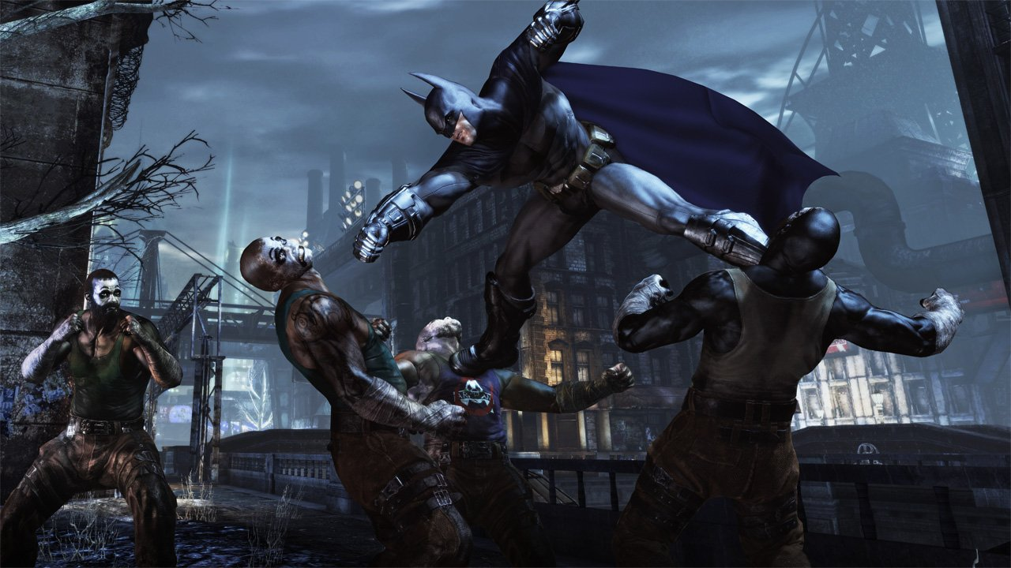

Diagram of Batman Arkham City

1. Visual

The visual aspects are essential to the success of this project. The problem arises with creating the optimal level design that sells the horror aspect of the game. Suitable lighting to create an eerie atmosphere and dark and gloomy texture on most objects and buildings in the game to give the player the horror experience they deserve. The game will be developed visually in HDRP(High Definition Render Pipeline) in Unity to enhance the graphics of the game once it is fully developed. The character models and the surrounding environment will most likely be modeled in Unity’s built-in computer software graphic tool, Probuilder and blender.

Cinemachine will be used to tackle a dynamic camera movement to allow the player to immerse the player into the 3D aspect of the game. The players’ perspective will be the manipulated variable throughout the game. According to a source [8], a first person perspective creates a more dramatic effect within the horror genre, whereas third person perspective establishes a omniscient perspective. This will allow the player to be immersed into the unfolding events of the game through a invisible third-party view. There will be certain set pieces in the game where camera movement will be static at one place in a part of the level. This is to create the illusion that the player is being watched by an enemy. This feature has been done in a very well-known game franchise, the Resident Evil franchise, particularly from the PlayStation 1 era.

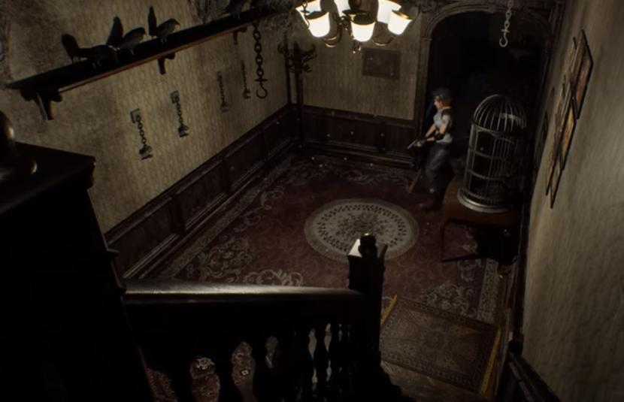

Diagram of Resident Evil 1(1996)

1. Story

The story of this game will be mostly drawn from the well-known webtoon, ‘Sweet Home’[11]. The story follows a young adult stuck in his apartment building when the apocalypse breaks out in the city. He has to navigate to the top of his apartment building fighting off monsters and other enemies. As he progresses towards his goal, he will encounter other survivors; some may be an ally to him, while some will stand in the way of his goal.

A rough storyboard will be drawn of the games’ narrative to give a clearer representation of the storyline of the game. The issue of the story will correlate with the coding aspect of the game. Research must be done on how to create a cutscene in a game properly. Pop-up dialogues will also be considered to further enhance the story of this game, along with the possibility of some of the characters in the game having a voice actor to breathe life into the characters of the game. The story narrative will utilize the show don’t tell approach, where players will be rewarded with plot devices that will be related to the story if they explore every level of the game thoroughly. Minimal dialogue and cutscenes will be done to create a smooth gameplay experience for the player and to maintain the pace of the story. The story will be relying more on terror instead of horror. As written in a source [5], horror is depicted as external, perceptible, comprehensible, and measurable. The story narrative is driven by terror which is depicted as anticipatory dread as it relies on what is unseen which then the players will use imagination to fill in what is unknown.

1. Gameplay mechanics

The gameplay mechanics of this game will be inspired by a myriad of adventure games for the combat and exploring aspect of the game. For the horror elements, aspects such as jumpscare will be inspired from well-known horror games such as Outlast, Alien:Isolation, Phasmophobia and Little Nightmares. Research will have to be done on those games on how the jumpscare element is implemented. The fear intensity of a set piece in a game will also have to be researched more. According to a source[6], one of the fear intensity can be implemented with sound effects. For example, a loud sound can be played to trigger the fear of the player when the enemy starts to chase after the player. The player can also be given no weapons to fight against the enemy, which leaves the player with the only option; to run away and hide until the enemy is out of range.

The enemies in the game will have certain attack patterns that the player can learn and dodge. This in turn can allow the player to create a chain of combos to counter the enemies’ attack pattern. There will be balanced weapons and ammo system in the game. The player will have to conserve ammo and strategically dismember the enemies[8]. This will be an additional gameplay mechanic to the player as there are many ways to completing this game. Players can either take a more direct approach and destroy the enemies or a more stealthy approach, evading and avoiding the enemies.

1. Sound

An important feature that is found in every horror game is sound effects. This is detrimental as this will create an eerie atmosphere for the players to create a more immersive player experience. I have researched many horror games and horror movie soundtracks. I researched some notable horror movies such as The Conjuring, Insidious trilogy, Dabbe, and many other horror movies. I particularly researched The Conjuring and the Insidous trilogy for the suspense that is formed in the soundtracks of these movies. However, with my knowledge of South East Asian movies, I also researched Thai Horror movies and Malaysian horror movies. Through the research I concluded that most horror movies rely on suspense sound effects to accompany the jumpscare. This ties into the horror games such as the infamous Silent Hill Playable teaser, which has impressive sound effects but rarely any soundtrack to aid the horror atmosphere of the game. To give an illustration of what that means, Silent Hill P.T’s storyline is basically the protagonist walking around the house in circles as minor details in the house changes as the character walks the same path over and over again. The sound effects were stubble to enough to create the eerie atmosphere and increase the fear intensity of the players that were playing the game.

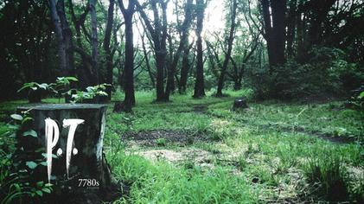

Diagram of Silent Hill Playable teaser poster

**Professional and ethical considerations**

BSC code of conduct

1. Participants were not exposed to any risks greater than those encountered in their normal working life.

*This project will not induce any harm to any of the players that play the finished product. The game will induce mild discomfort, stress or anxiety, bright or flashing lights, loud or disorienting noises, smell, taste, vibration, or force feedback. The game will not impose any risk of harm that is greater than in ordinary life.*

2. The study materials were paper-based, or comprised software running on standard hardware.

*Participants are not exposed to any risks associated with the use of non-standard equipment. The participants will mostly be using standard PCs to experience the finished product of this project.*

3. All participants explicitly stated that they agreed to take part, and that their data could be used in the project.

*Participants are briefed on the genre of game they are experiencing. Participants will require consent on playing a survival horror game which will include jumpscares and moments of mild stress and anxiety. Covert observation, deception or withholding information are deemed to be high risk and require ethical approval through the relevant C-REC.*

5. No information about the evaluation or materials was intentionally withheld from the participants.

*This project will not withhold any information from participants or mislead them in any way.*

8. Neither I nor my supervisor are in a position of authority or influence over any of the participants.

*A position of authority or influence over any participant must not be allowed to pressurize participants to take part in, or remain in, any study.*

9. All participants were informed that they could withdraw at any time.

*The participant can choose to withdraw or stop playing the game if it is deemed too scary or if they are experiencing a level of stress and anxiety than predicted.*

10. All participants have been informed of my contact details, and the contact details of my supervisor.

*All participants have both me and my supervisor’s contact details. They will be given out at the start of the playtesting.*

11. The evaluation was described in detail with all of the participants at the beginning of the session, and participants were fully debriefed at the end of the session. All participants were given the opportunity to ask questions at both the beginning and end of the session.

*Participants will be briefed on the concept and genre of this game before they start playing the game. Participants will be debriefed and asked for criticism on the project.*

12. All the data collected from the participants is stored securely, and in an anonymous form.

*The data collected from this project will be stored securely and will not be misused or sld in any form. The data will only be used exclusively for this project and it will be stored once this project is completed.*

**Requirement analysis**

The main components of the game will be a player with general player movements such as walking, running, jumping and dodging. The player will be navigating through a series of levels to get to the top of the apartment. The player will be able to interact with NPCs(Non-playable character) such as engaging in a conversation with them. The player will be able to pick up weapons and attack the enemies throughout the game. The player will be able to carry multiple items such as an inventory system where the player can cycle through a number of weapons. From a level design aspect, the levels in the game will progressively be more difficult but to help balance the difficulty of the game there will be safe points in every level to avoid player from giving up too quickly. The player will be able to interact with certain aspects of the environment, one of which is picking up power ups or a form of currency for the player to upgrade or buy new items. There will be a possibility of adding multiplayer functionality if time allows it.

Within the gameplay aspect, a feature that is most likely to be implemented as a core element of the game is a feature where the player can detect nearby enemies through the static sounds from a cell phone. The player will be equipped with a cellphone at the start of the story. If there is an enemy the static noise will increase, alerting the player that there are enemy nearby. This feature is heavily drawn from the popular PlayStation Portable(PSP) game, Silent Hill: Origins.

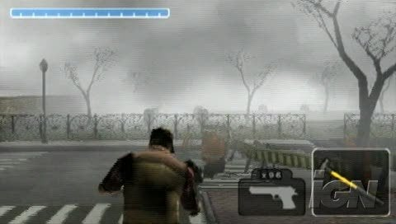

Diagram of Silent Hill: Origins

This game will not require any high-end hardware to run. A basic laptop with a mid-tier graphic card will be able to run this game smoothly. The game will have controller support so the player will have an option to choose between keyboard and mouse or controller. The game will have a file size of 5-10gb. The player will not require a large storage to download and play this game.

The game will be teen rated. Any individual aged 13 and above will be able to play this game. Individuals under the recommended age will possibly experience a higher fear intensity, stress and anxiety. The game will not be too challenging, with puzzles that are easy to solve but still require a little thinking and intuition from players to solve. The game mechanics will be easy for the player to master and will not overwhelm the players. The player’s movement and interactions with the environment are kept to the minimum to prevent the players from being frustrated with the mechanics of the game. The experience will not be reduced for players with disabilities.

**Game Design and Development**

**Functionality**

There is a lot of functionality in this game. Majority of the game mechanics are made in Unity Game Engine. User Interface such as Start screen, pause screen are made for the game as well. They are made to match the horror theme of the game. There are also audio designs that is essential to give the eerie and horror effect to the game. Level design are also taken into consideration.

Initially in the early stages of the development, there were myriad of ideas thrown around during the research phase. I overestimated myself on wanting to put a huge amount of features into the game. Unfortunately, I could only create the basics of the game and could not implement the features i wished for in the early stages of development for this project. I also understood my level of understanding on game development and game programming are not enough to create a game with features seen on AAA games or even indie games. For example, a feature I wanted to implement was Free Flow combat system. [13]Free Flow combat system is a system which allows players to lock on to one enemy and dealing damage to it and moving onto the next enemy without destroying the flow of attack. Essentially the players can lock on to another enemy once the initial enemy is dead. This goes on until either the  players gets killed by the enemy or the players defeats all the enemy in that confined area in a certain level.

I found this rather hard to implement as this requires further testing and research. My lack of experience in game development did not alleviate my workload on making this feature work as well. This is due to the fact I have only made First person shooter game in my past games. I wanted to learn a new way of player interacting with enemies by melee combat. That itself took me a few weeks to learn and code into the game. And it is still very clunky and does not function properly half the time.

I also wanted to have a complex sound effect when the enemies is detected by the player and also a different sound effect when the enemy is chasing the player. Initially the plan in early development stages is to have a loud violin string sound effect similar to the insidious movie that plays when the enemy detects the player before it starts chasing the player. This would generate a sense of tension and fear for the player to provide an immersive gameplay experience.

The sound effect would then switch to a chasing sound effect where the enemy is trying to track down the enemy. This would be initially be heavily inspired from the Metal Gear solid series when the main character, Snake gets noticed by enemy and the infamous soundtrack plays when the enemy is chasing him down.

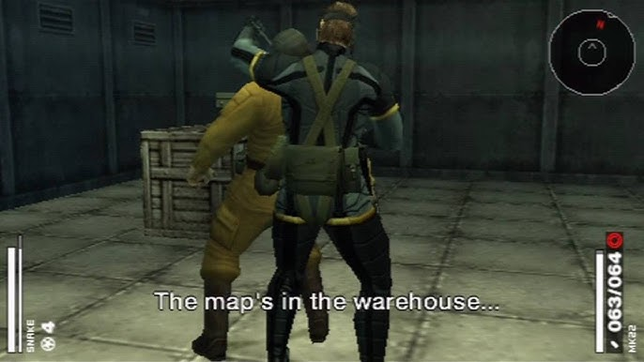

Diagram of Metal Gear Solid portable ops on the PSP

But eventually since this is a horror game, I decided to pick a more horror appropriate sound track. I finally decided on a soundtrack from another famous horror movie, which is The Conjuring.

As development progress I tried to implement this feature into the enemies script but I failed to do so as it is too complex for me to handle. Due to time constraints I made the hard decision to abandon this feature and worked on core features of the game and trying to perfect those features as much as possible. For the background music I chose a silent hill soundtrack which is suitable for the atmosphere for the game.

**Script and game object**

There are a number of scripts and game objects that are used during the development of this game. There are some scripts that were used in the initial development of the project. But due to circumstances there were not used as the projects develops into the later stages.

**Scripts**

PlayerController Script

There are a myriad of variables and methods in this script. The PlayerController script is used to control the basic movements of the player. It is used to initiate the movements of both the player itself and the camera that follows the player. The new unity input system was used to create the player movement. Animations of the player are also initiated in this script. The strafing and walking animation of the player are initiated in this script.

Audios of player walking and attacking are also initiated in this script. Unfortunately, due to many trial and error, I am not able to get the audio to work properly. Due to time constraints I do not have time to fix this issue. There were also comments at the end of the script to initate player sprinting. But once again due to time constraints, I am not able to implement this feature into the game. Many research was done on this issue as it is difficult for me to implement this feature without a myriad of bugs and glitches appearing in the console. Many comments were added throughout the script to create an easier understanding of the script and which part of the scripts initiates and operates which part of the player controller.

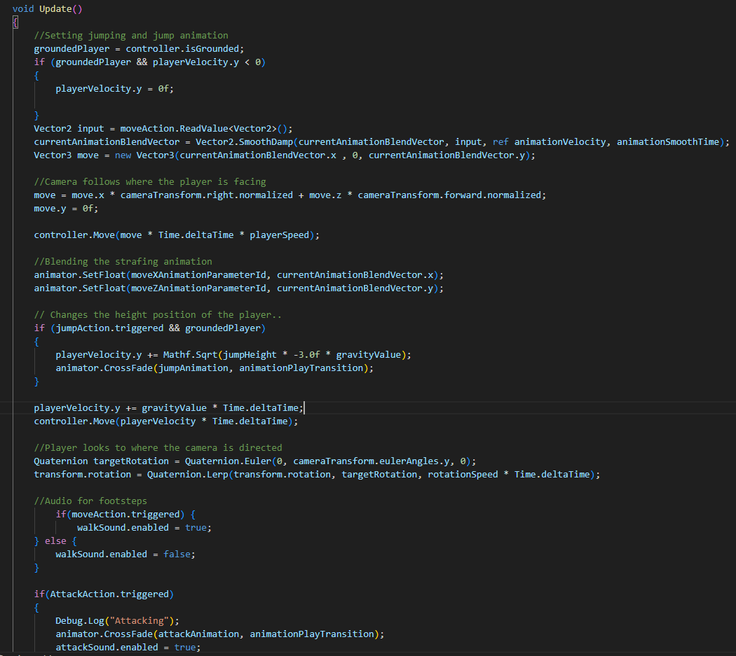

Diagram of the update method in the player controller script

The player controller script is closely related to the player input actions. There are more than one way to move the player in this game. I have implemented 2 types of control scheme into the game, both keyboard and mouse and using a gamepad. With the new unity input system, this feature was still challenging to implement as I encountered many issues when trying to implement this particular feature.

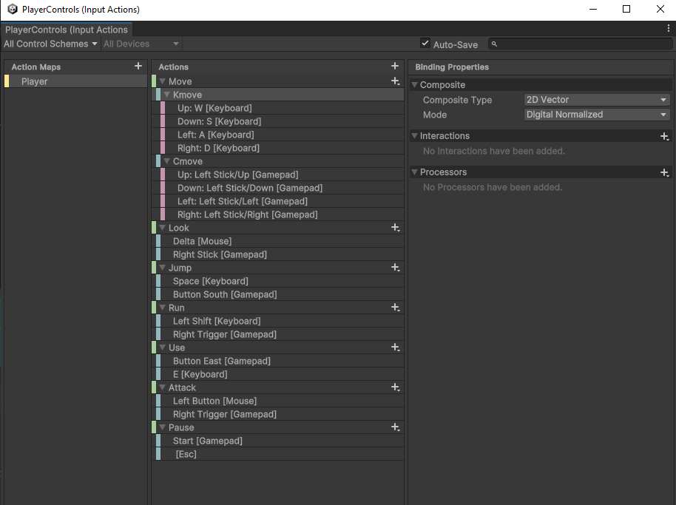

Diagram of the control scheme for the player inputs

Insects Script

For the enemies there were many scripts that were created to build the enemies animation and moveset. The Insects Script primarily detects the attacks that are initiated by the player. The take damage method is created here, which shows that it will trigger the die animation if the enemies’ health is reduced to 0. If the enemies’ health is more than 0, then it will trigger the get hit animation as it takes damage from the player spear.

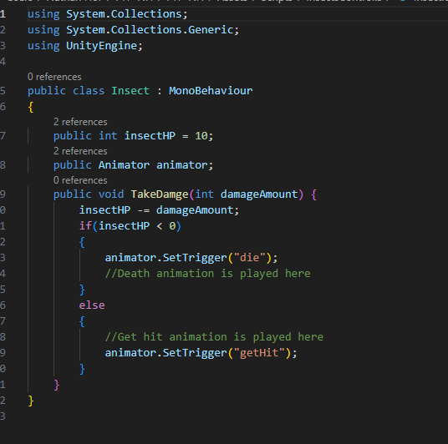

Diagram of the Insect Script

InsectChase, InsectPatrol,InsectIdle, and InsectAttack

These 4 scripts are create with heavy relations to the enemy animations. These scripts are created and attached to the respective animations that correlate to each respective movesets, but most of these scripts are similar with minor differences. These scripts are update on both the OnStateEnter method and the OnStateUpdate method. When the enemy moves from one animation to another, the respective animations are set to false.

For example, in the InsectIdle script, 3 variables are initiated in this script, the timer, player and the chaseRange. The script is initiated when game is started and the enemy is in the level. After 2 seconds, the enemy will start to patrol around the level, so it changes from idle animation to patrolling animation after 2 seconds. If the players moves into the chaseRange of the enemy, then the enemy will switch from patrolling animation to chase animation. This concept is done with heavy relations to navmesh agents and using waypoints to create the pathway for the enemy to patrol around the level.

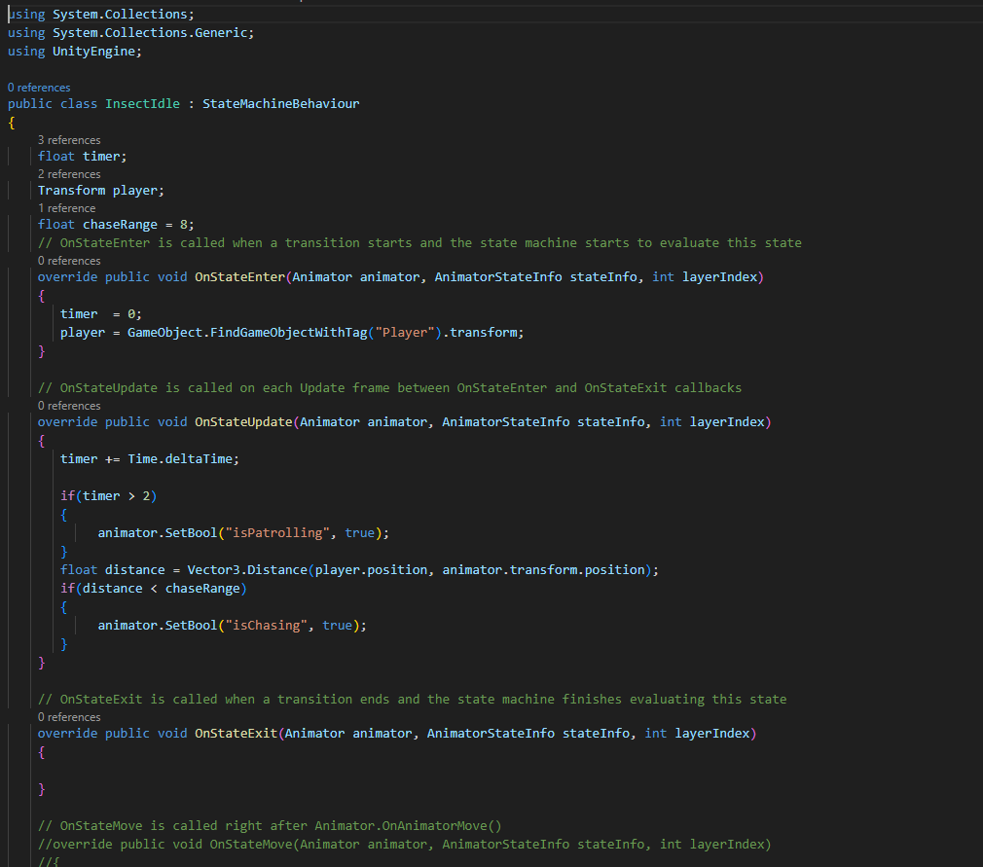

Diagram of the InsectIdle Script

The InsectAttack,InsectPatrol and InsectChase scripts works in similar fashion, where it switches from one state to another once it detects the player or once the player is out of it’s range.

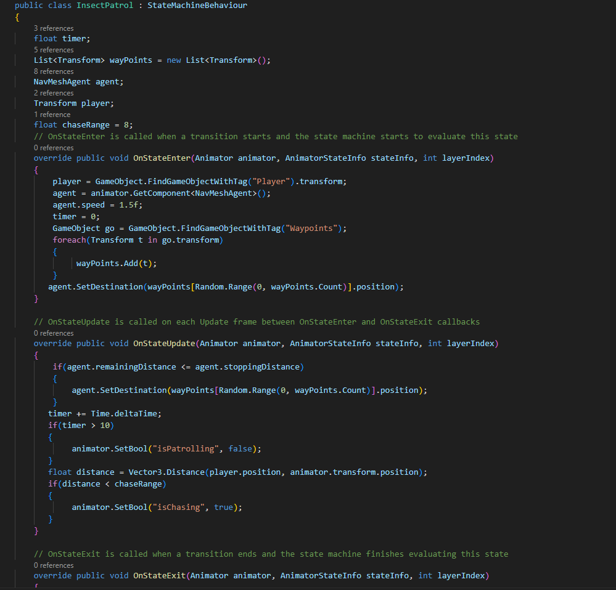

Diagram of Insect Patrol Script

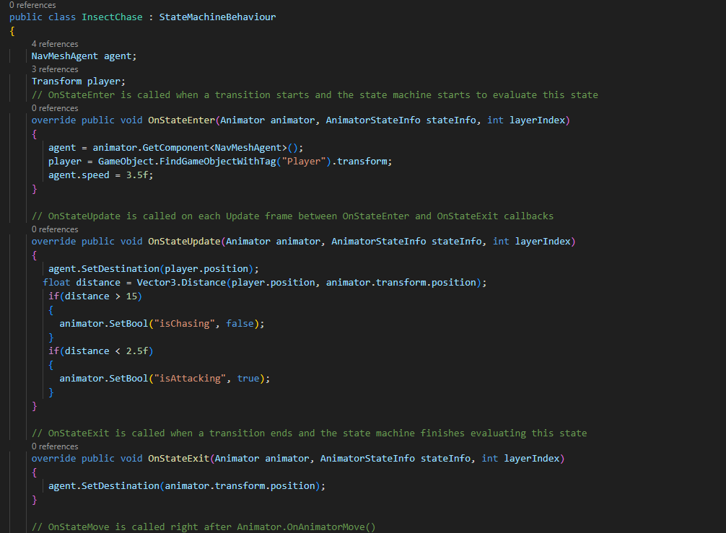

Diagram of Insect Chase Script

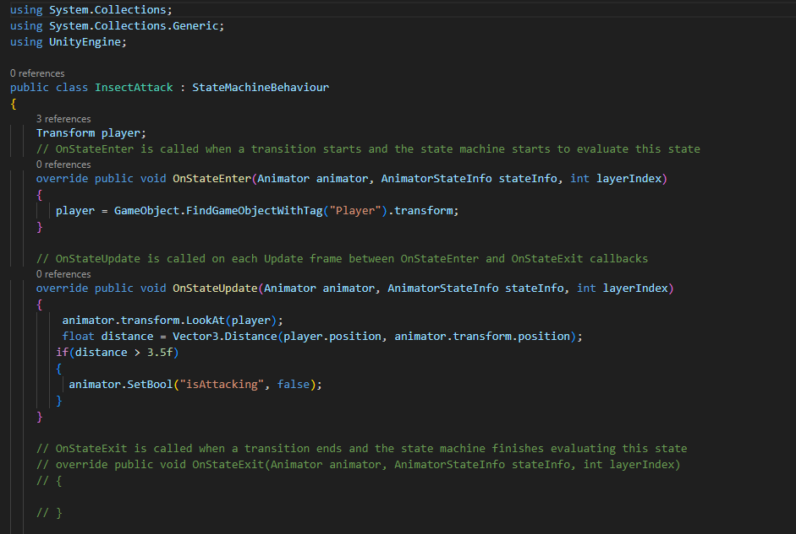

Diagram of Insect Attack Script

Door Script

The door script is mainly created for interaction for the players to open the doors to the apartment rooms in the game. The concept is that the player will be able to open the door once the player is in range of the door. Then there will be an audio played when the door is opened by the player. There are methods to control the rotation of the door and to determine when the door should start the coroutine of rotating that only happens when the player interacts with it.

Below are the variables initiated for this script to function. This script is attached to the doors that are created in the game to allow the players to fully be able to interact with them. The doors also had to be put in the useable layer in unity to allow the players to interact with them.

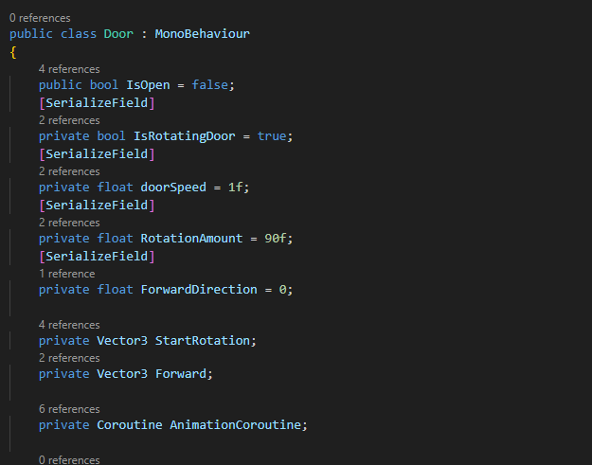

Diagram of the variables initated in the Door script

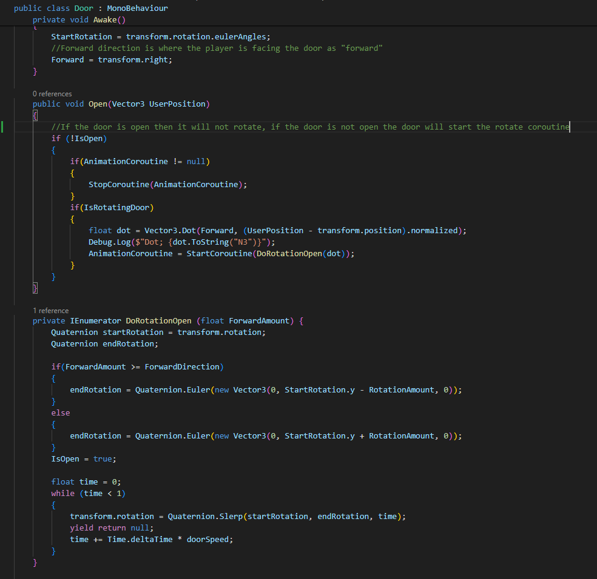

Diagram of methods used in the Door Script

PlayerActions Script

This particular scripts relates heavily to the door script as this script plays the audio of door opening and allows the player to interact with the door itself. It is shown in this script that the raycast method is used for the player to determine the door is in range and for the player to interact with the door in the game. Initially I wanted to have text appearing on the door to instruct the players the button to press to open the door. But due to many trial and errors the text revealed to be colliding with the doors and only showing the texts partially. Due to time constraints I was not able to fix this features which extends from the door script.

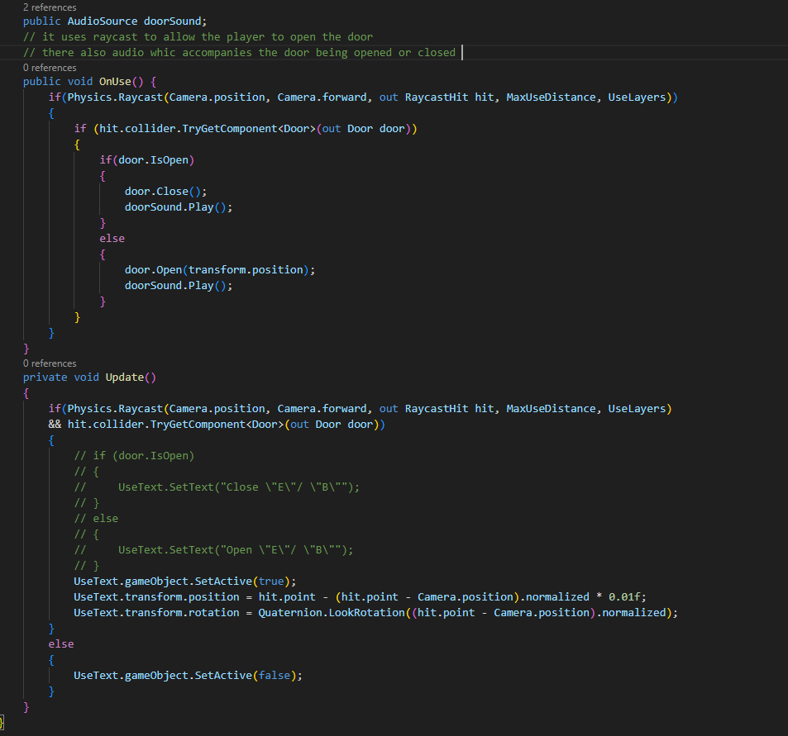

Diagram of PlayerActions Script

Weapon Script

The weapon script is simplistic yet important to the player moveset. This script relates to the insect script. This script is attached to the weapon that the player is carrying, which is a spear. The scripts determines whether the weapon collides with the enemy. If the spear collides with an object that is labelled enemy then it will deal damage to the enemy. However, I was not able to get this feature to work as there are many unforeseen variables that prevent this feature from being implemented. I spents many weeks trying to determine the cause of this issue but to no avail.

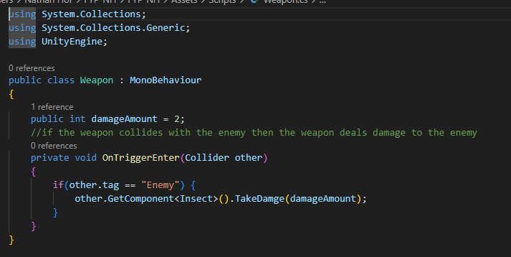

Diagram of the Weapon Script

MainMenu Script

This script is important for the menu scene at the start of the game. The players will see this scene and interact with this before jumping into the game. It uses the scene management library in Unity to switch the scene from one to another. There also buttons on the main menu for the player to click on, the play button, the options button and the quit button. The options button allows the player to change the volume of the game. The quit button allows the player to close the game and the play buttons switches the scene to the first level of the game.

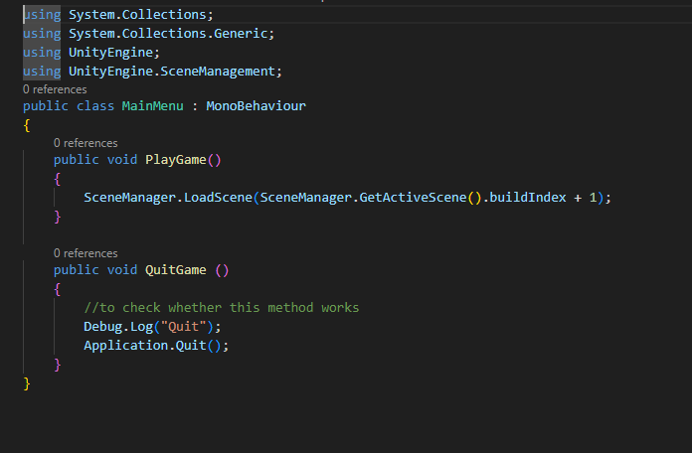

Diagram of the Main Menu Script

Next Level Script

The next level script is similar to the main menu script. This particular script changes from one level to the next when the player collides with a gameObject. The player will collide with the door on each level with this script attached to it to advance to the next level.

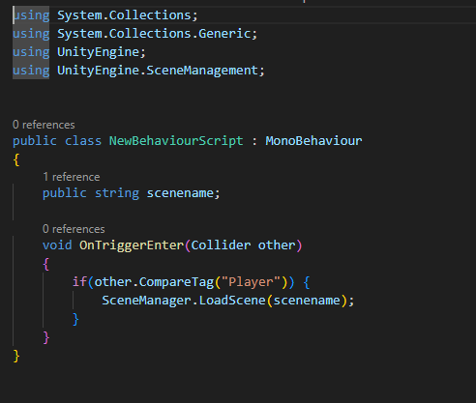

Diagram of NextLevel Script

WinLevel Script

This script is similar to the main menu script. This script has 2 functions. For the player to play again since the player has finished the game, or to quit and close the game.

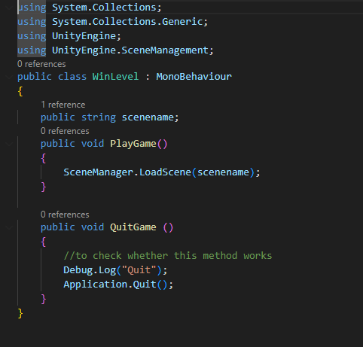

Diagram of WinLevel Script

Game objects

Most of the game objects that are used in this game are taken from the Unity Asset store. Myriad of research were done on creating an optimal horror level. I made sure the game objects such as the table and the sofa and other house appliances did not hinder the player’s ability to explore as much of the apartment as possible without being blocked by the objects. I also made sure to create a realistic environment for the player to immerse into. I research a couple of apartments and what they usually have inside of an apartment to create an immersive and realistic apartment for the player to explore.

I gave a hockey stick as a choice of weapon to the player as it fits the narrative of the horror story. I created animation for the hockey stick, both swinging and idle animation. The swinging animation will be the attacking animation

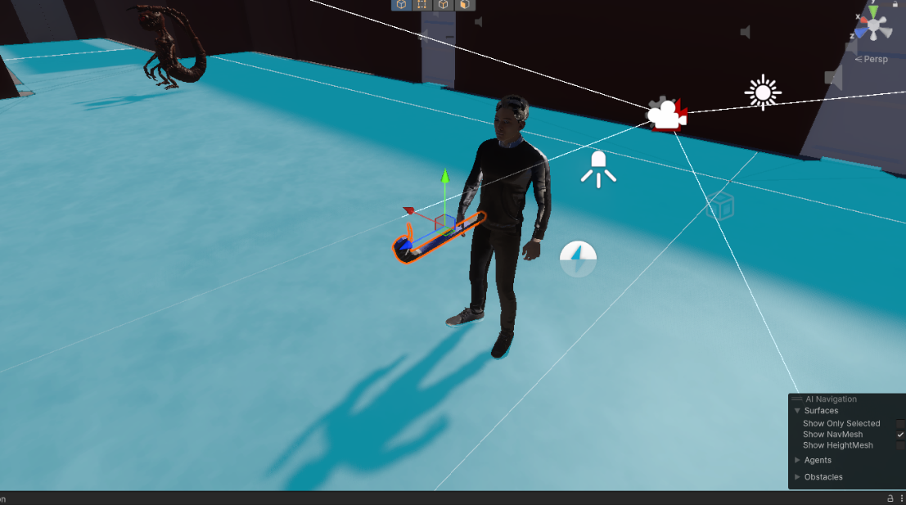

Diagram of character holding the hockey stick

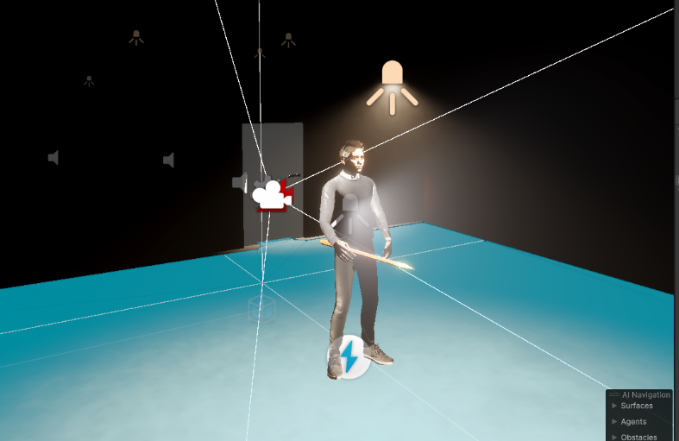As development progressed I realised that I could not make melee attack animations efficiently without glitches and bugs. So I have decided to switch from melee attacks to using a crossbow as a form of attack. I initially researched on ways to create a melee attack animation. I encountered the issue when I was following this youtube tutorial that I have saw online and tried to follow the steps. After many trials and researching, I managed to form a simple melee attack animation. Unfortunately, due to bugs and glitches I am unable to correct the damages and health between the enemies and players.

Diagram of player holding a spear

The enemy model was taken from the unity asset store. I chose these enemies as I felt they fit into the narrative of the game. For the final boss I increased the size of the enemy and added a roar sound effect to increase the fear intensity of the final level of the game.

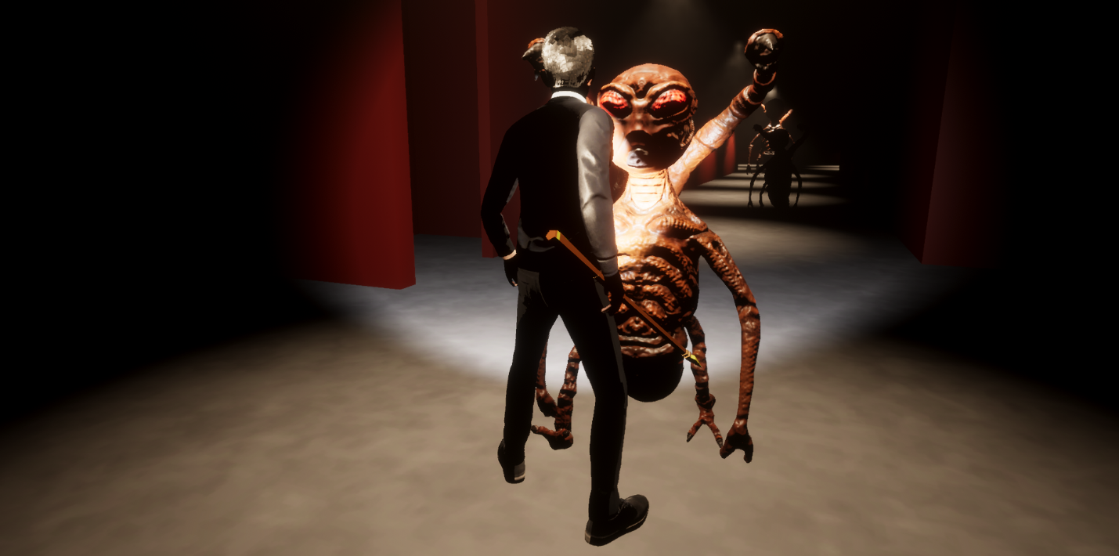

Diagram of the enemy approaching the player

The enemies all operated in the similar way, using the navmesh layout to navigate the and patrol the level, there is many states that the enemies are in. The enemies are in idle state, patrol state, chase state, attack state get hit state and the die state.

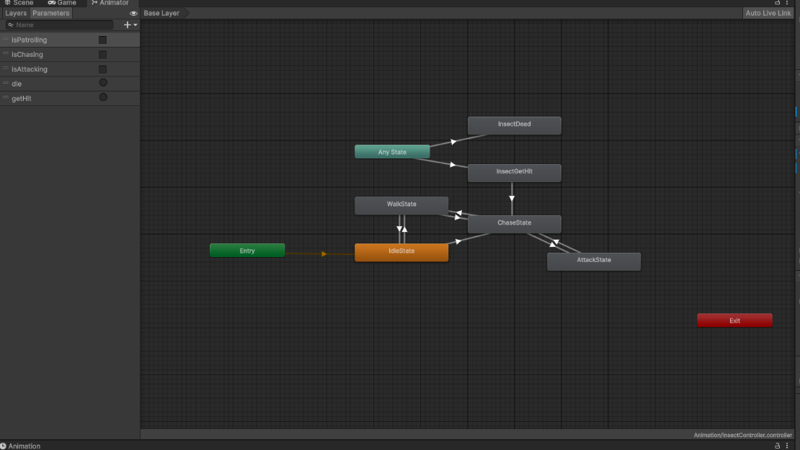

Diagram of the Animation tree for an enemy

As shown in the diagram above there are arrows which indicates the transition from state to another. When the game starts the enemy will be in idle state for a few seconds before starting to patrol throughout the level. As the enemy detects the player it will go into the chase state from patrol state, thus the enemy will chase the player. If it catches the player it will initiate attack state and if the player attacks the enemy it will initiate the get hit state. Once the enemies health is reduced to 0, it will transition to the die state where the enemy dies. If the player manages to escape the enemy and hide, then the enemy will return to patrol state. These states are controlled by Booleans that are implemented on each transition of the states.

For the user interface of this game, there was a start screen, pause screen and a win screen. The start screen contains a few menu options, which has the play button, options button and the quit button.

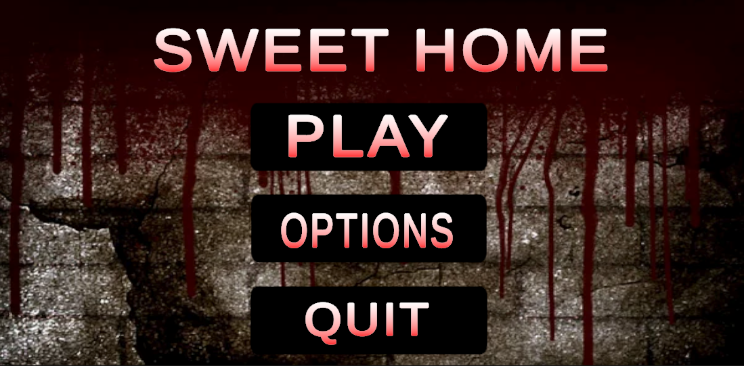

Diagram of the start screen of the game

The player can pause the game anytime in the game and the game will freeze all movement will be paused in the game except the camera movement. This is to allow the player to scan the surrounding of the player and give time for the player to get calm to continue the game.

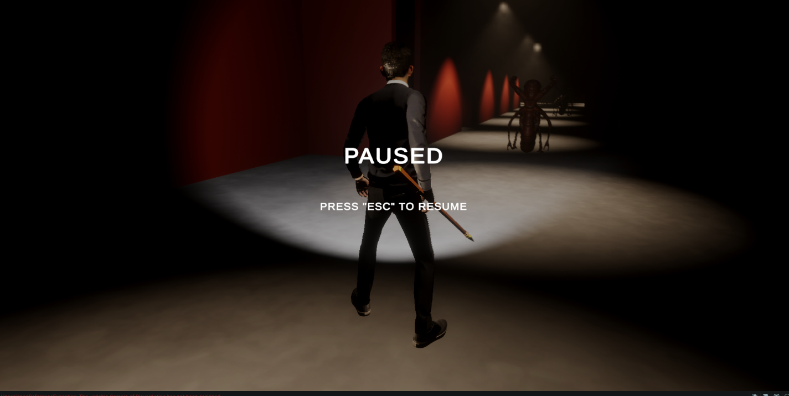

Diagram of the Pause Screen

The Win screen appears when the player finishes the games. The player will be able to play the game again or quit and close the application.

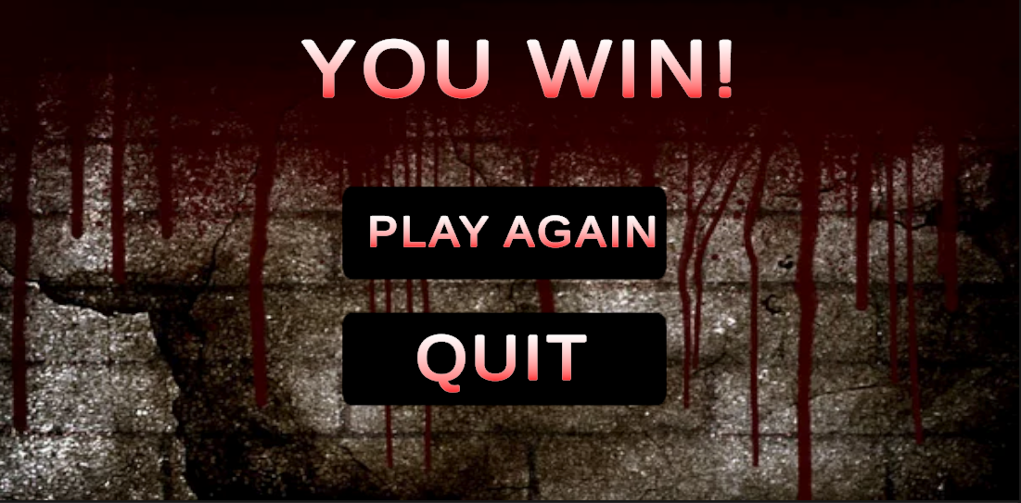

Diagram of the Win Screen

**Game Production technology process**

Initially, during the early phases of this project I wished to explore another game engine, which is Unreal Engine 5. [14] Unreal Engine 5 is a 3D computer graphics game development tool created by a company Epic Games which uses the C++ programming language.I did research on the game engine and the functionality of it through youtube videos and online websites. I ultimately decided on using Unity Game Engine instead. This is because I am unfamiliar with C++ programming language and more familiar with C# as i have worked with C# programming in Unity Game Engine before.

Unity

Unity is a 3D game engine designed for all levels of game developers. At the start of development, I was too ambitious and desired many features in this game. I did months of research on how the games is designed and how the functionality of the game. I researched horror games such as Silent Hill, Resident Evil and Dead by Daylight. I then started developing the game after 2 to 3 months of research. I started developing the levels in the game, using ProBuilder and other resources found on Unity Asset Store.

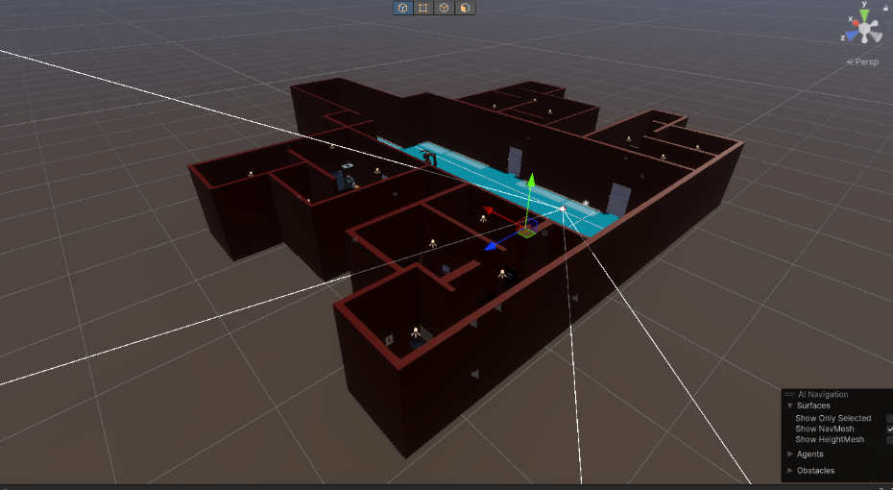

Diagram of the layout of the first level of the game

I studied game levels from Silent Hill and how they developed the dark and gloomy environment in that particular game. I decided to make the walls of the level red to create the evil and dark atmosphere throughout the game. I also used the studio light in the game to create a dim look. I then attached a light source to the player as a torchlight to navigate through the dark atmosphere of the game.

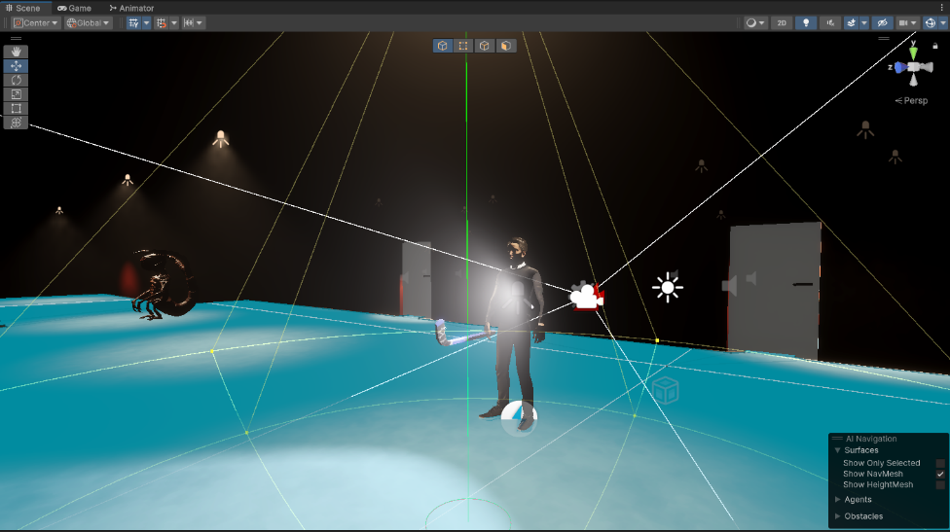

Diagram of the light attached to player

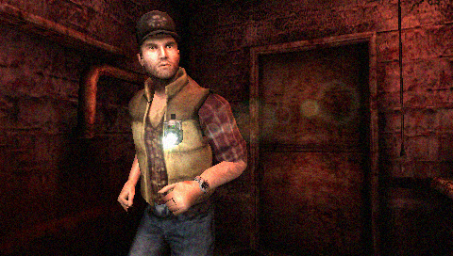This method of attaching the light source to the chest of the player is inspire from Silent Hills:Origin, as the main character in the game has a torchlight attached to the chest of the player as well.

Diagram of light attached to character from Silent Hill Origin

I then developed the player movement such as running and attacking. I followed tutorials online on how to do so. There were various ways such as using colliders and initiating the concept of collision with game objects with selective tags. But ultimately for my own conveniences i used the animation as a way to detect, patrol and attack the player. Nav-Mesh agents were implemented to allow the enemies to patrol the player. The concept was to bake each level with the navmesh layout installed as a feature in the unity game engine. I then created empty game objects labelled as waypoints to provide the enemy with a pathway to patrol around the level.

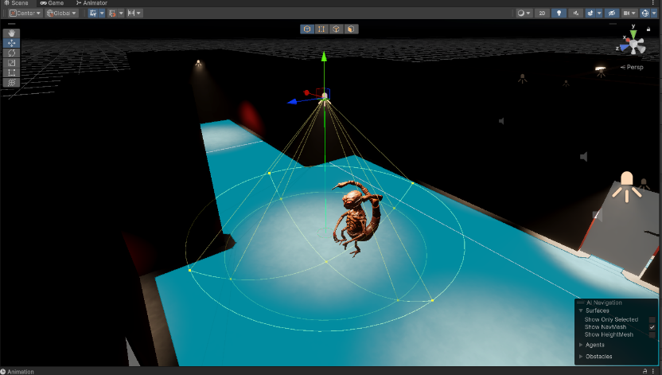

Diagram of navmesh layout of a level with an enemy on it

Once these 3 important components are completed, I proceeded to create more level and add more enemies to each level. I then proceeded to tweak some changes throughout the game as development progresses.

I also have created simple camera movements using cinemachine. I initially wanted to go for a 1st person camera look for the game. This is because from research that I have done most horror game that are popular within the gaming atmosphere are mainly first-person horror game. However, after further testing it did not look optimal as the level that I have created are too small to create the sense of dread and doom with a first-person camera. Not only that, due to the small confined levels the first-person camera had trouble locking into the player due to the fact it kept colliding with the walls and also other objects in each level.

From the diagram above it can be clearly seen that player with a third-person camera is more immersive and creates a better player experience compared to the first-person camera. After doing the prototype testing to 3 individuals they concluded that it was a better experience compared to if it had been a first-person camera.

Mixamo

Mixamo is an online website powered by Adobe that is a model generator. There is a selection of models on this website which you can pick and choose from. I choose a model that resembles a normal everyday worker to fit the narrative of the story. Basic animations can also be chosen on the website, such as walking animations and jumping animations. I chose both jumping and walking animations, as well as a idle animations to give to my character. I then followed a youtube tutorial on how to rig it in Unity. The website is pretty useful for beginners like me who struggle to make their own unique character.

Probuilder

Probuilder is a built in feature in unity which you can download in the unity registry. This features allows a person to build levels, walls and other game objects with much ease compared to using the basic building features pre-installed with the basic unity package. One of the many useful features are creating edge-loops to split a game object such as cube or a cylinder. These particular features help me sculpt certain game objects that can’t be found on the Unity Asset store.

**Project method**

Agile development

[15]According to an online source Agile development is a project management approach that divides the project into different phases and focuses on continuous development and collaboration. To put it simply, agile development approach is a process which the individual works on the project in small increments to achieve the goal as a bigger picture. There are a myriad types of approach to agile development,one of which is used in the process of the development of this project, the Kanban board in Github. There is also another agile development approach, which is Scrum. [16] Scrum uses a system called ‘Sprint Cycle’ to create the process in which the individual goes through a cycle where a goal is at the end of the cycle and the individual is given a time frame to finish it which typically lasts around 1 to 4 weeks.[17] This agile approach does not suit my workflow as I personally feel that the timeframe to finish a certain sprint cycle is not optimal and efficient and puts a certain level of stress on my mental health. In the end, after thorough research and past experiences I have decided to implement the Kanban board in github with the development process of my project.

The Kanban board in Github helps organize and prioritize the workload during the process of the development of this project. It helps divide the workload so I can determine which feature of the project I should work on first. An example of the Kanban board can be shown below, which is taken from the early stages of my project development process.

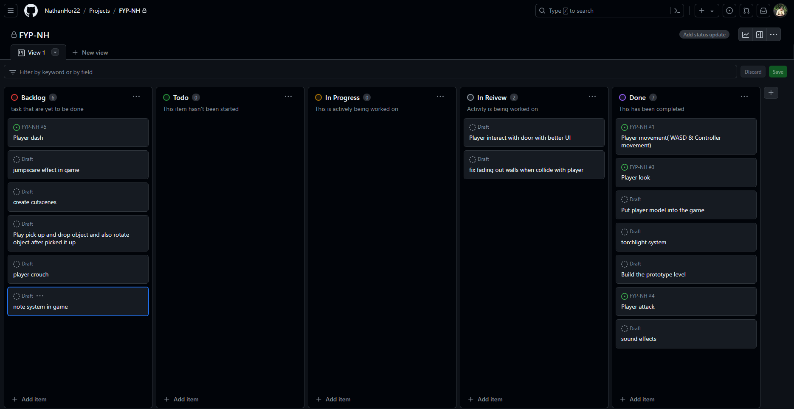

Diagram of my project’s Kanban board in Github

From the diagram it is clearly shown that there are four columns in this Kanban board. From the left there is Backlog, To do, In Progress, In Review and Done. Additional columns can be added but for the scale of this project these 5 columns are sufficient for me to organize and develop this project. In the Backlog column is where most of the features that I have thought of and want to implement into the project are put in. I then decide whether they are features that are possible to be implemented into this project. Once I decide the features are possible to be implemented into the game, I move the task from the Backlog to the To-Do list.

Once I have started working on them I will then move the task to the In-Progress column.This is where I start to work on the task, some of them take months but most take weeks. Once the tasks are done I then put the task in the In-Review column. I will then debug the scrips and game objects implemented into the game. This determines if there are any bugs or glitches after the implementation of that specific feature. After some testing and there are no bugs or glitches, I will put the task in Done.

Using the Kanban board provides me with a sense of achievement and keeps me organized. This is because everytime a task is put into the done column it gives me a sense of accomplishment and visually tells me there is progress in the development of this project. There are no sprint cycles to be done since this process of agile development does not need a sprint cycle. This approach only relies on the task which are placed on the columns to determine what tasks are unfinished, finished, needed to be reviewed or done.

User Test

Aim

The aim of the user test is to determine if the game is in a playable state and there are little to no issues on the game. I provided the game to a few individuals who are willing to test my games.

Methodology

I created a simple questionnaire with some questions on it for participants to answer once they have tested the game. I then have a small feedback session with each individual participant to allow them to provide feedback.

Survey Participants

I gave 3 individuals to test my game and see how they reacted to it. I tested to see if they fear certain parts of the game. I also tested to see if they enjoyed playing the game.

Data Collection

Before testing the game, I gathered 3 individuals who were my friends and explained to them the basis of this survey. I told them the genre of the game I was producing and requested permission from them to do this survey. Once everyone understood and was comfortable with testing the game, I then gave them the github download link and instructed them on the process of downloading the game and running it. Each participants spend around 5-10 min playing through the whole game. Most participants were satisfied with only one playthrough of the game.

Feedback

The individuals were not fearful of the monsters of the game or even the eerie atmosphere of the game. One individual even comments on the monsters on the game to be funny-looking. I asked them a few questions regarding their experience of their playthrough of the game. One individual said the game was too simple and there was not much player retention. He also said that the attacking animation for the player was not working occasionally. There were many other issues highlighted by the 3 individuals.

**Project planning**

Gantt chart

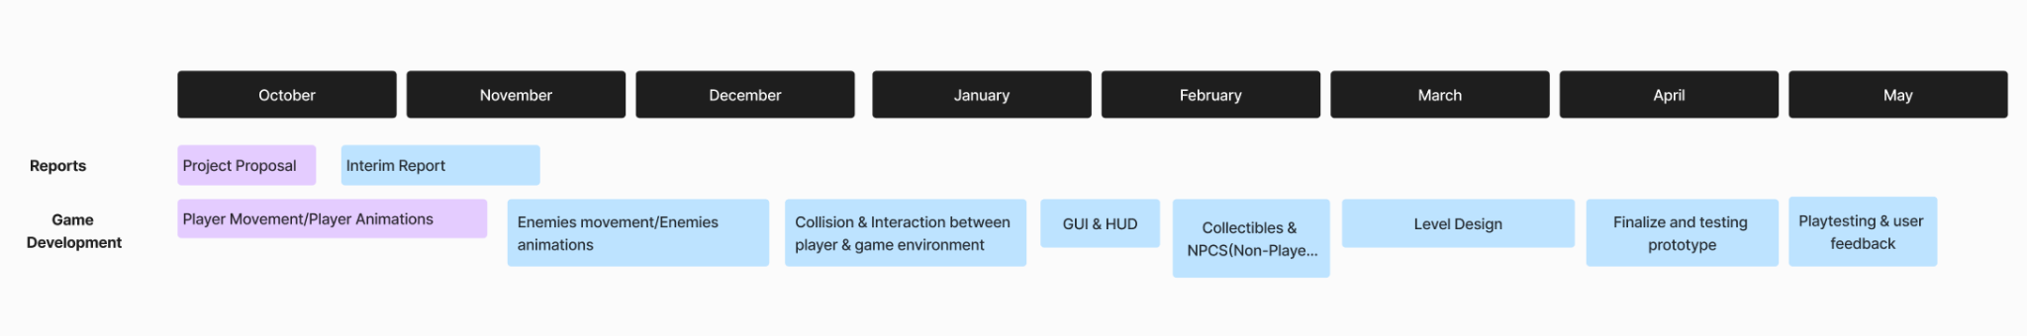

Early stages of the game

As seen from the images below, there is decent progress in the development of the project. Player movement has been implemented into the game. The player can move around and jump. Visually there is a Cinemachine attached to the player to allow the player to look around the player and it’s surrounding environment.

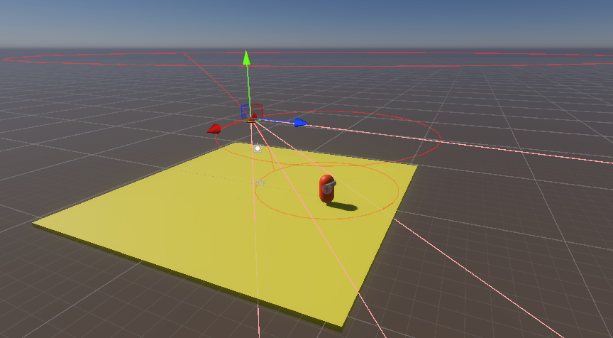

Diagram of Cinemachine Freeloook attached to the player

Control Scheme is also implemented to provide options for the player to either use keyboard and mouse to move around or to use a controller to do so.

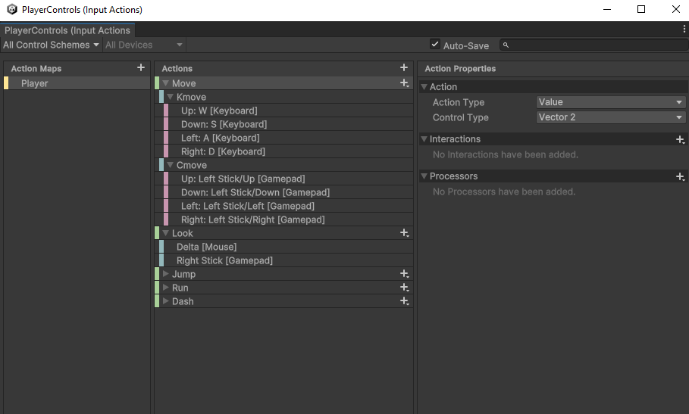

Diagram of Control Scheme for the player

The current issue that is being worked on is allowing the player to dash, including a stamina system to balance the dash feature. There is steady progress being made on the project and I hope the progress continues to be steady until the completion of the project.

My kanban board is at it’s early development stage and there is many features and task yet to be done and sorted. I intend to start my research on implementing the player melee attacks and how it can done efficiently. I also want to improve on more of the basic foundations of the game. The diagram below is the current state of my kanban board.

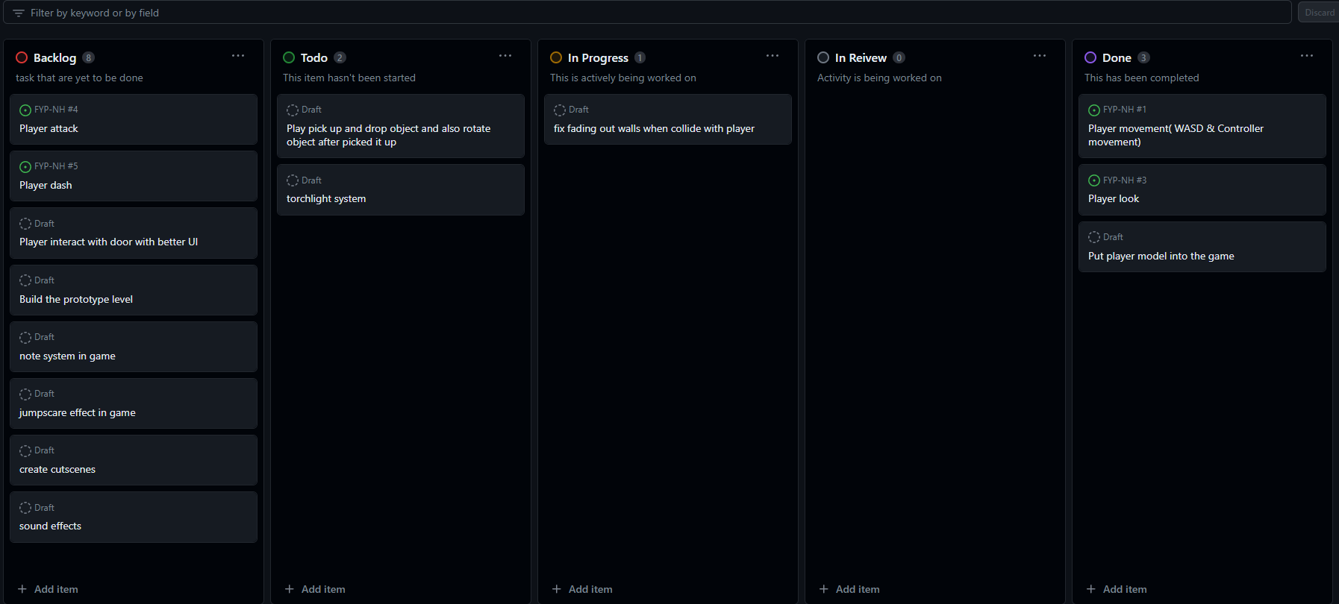

Diagram of my kanban board in the early stages of development

Mid development stage of the game

At this stage the game is halfway done, the model of the player is placed into the game. There is still a long way to go in the development process of this game. The enemies’

AI are still being development at this stage of development. Only the model and simple tracking are added to the enemies. The level has been designed with lighting and interactions with the door of the game. The player at this point of the development stage can interact with the doors of the game. The attacking animation of the player is still being development and will continue to do until this feature is fully functional.

The animation tab is important in the development of this project. The animator controllers created in this project gives motion to all the characters in this game. The enemy animator controller has many states which it switches from one to another.

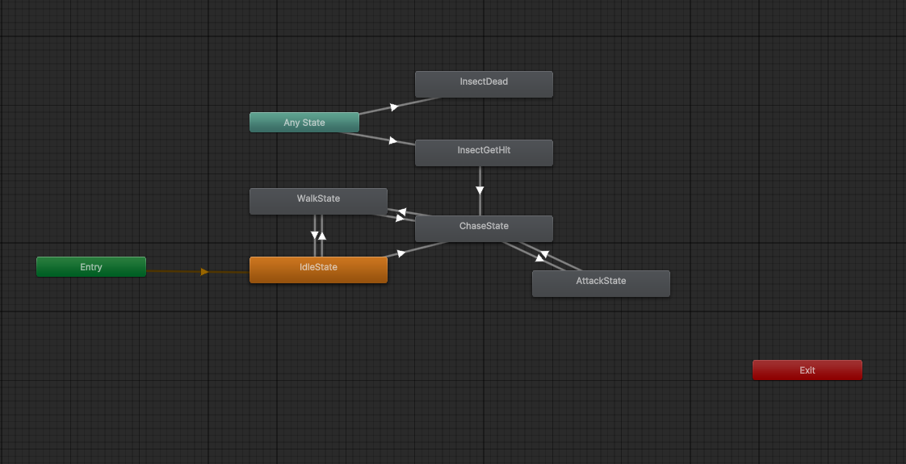

Diagram of Enemy Animator Controller

This the final product of the insect animator controller. This controller controls most of the insect moveset, ranging from idle animation to walking, chasing, get hit and die animation.

As previously said, the management of this project is done using an agile development approach and the approach I have applied to this project development is the kanban board. Here is the current state of the Kanban board.

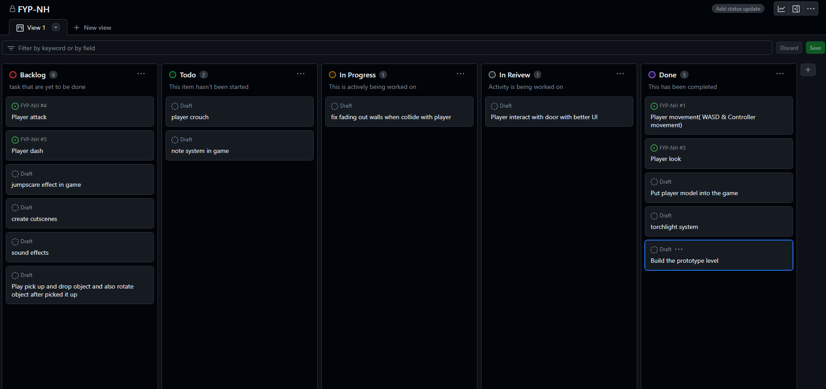

Diagram of my Kanban Board at this current stage of development

As shown in the diagram above, there is still so much more to be done and more development needs to be done. But the Kanban board has been effective in showing what needs to be done and what has been done throughout the development process of this project.

End of the development process

Due to time constraints this is the final product at the end of the development process. There are many features that are not implemented or altered during the course of development. There are a few backlog features that were not able to be featured into this project. The free flow attacking system with attack combos were not able to be implemented into this project. This is due to the fact that after many research done on the feature and many implementations have been done, I am not able to bring that feature into this project. This is due to my lack of knowledge in the game development process and time constraints on this project. I do not have a team of programmers guiding and aiding me during the course of this project. I also have other academic commitments and other commitments that prevent me from spending more time on this project. I will however continue to work on this project after this cycle of development. Here are some images of the final product of the game.



Diagram of the Start Screen of the game

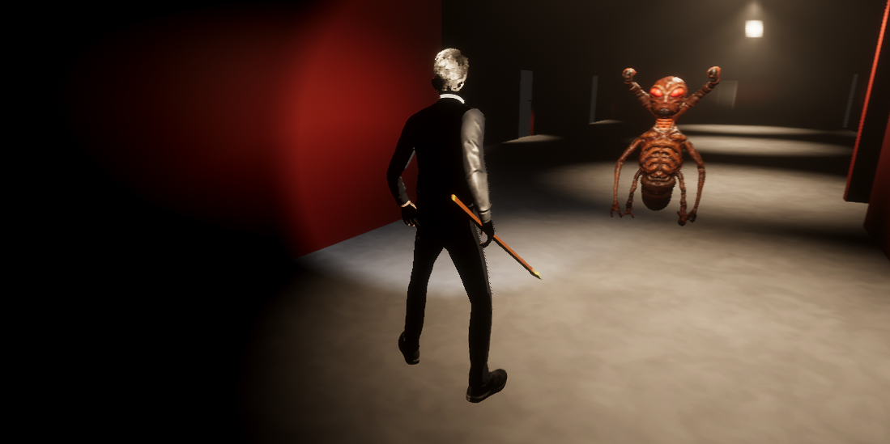

Diagram of the game being played

As shown in the images the game has a solid foundations with basic features implemented into the game. I am however not satisfied with this quality of work and strive to continue working on this project after this cycle of development. This is because I believe this project can be further improved upon.

**Conclusion**

**Results**

The development of this game was not what I envisioned it to be. There were many features abandoned due to time constraints and the limitations of my knowledge. However I have learnt many new programming concepts and improved my general skills in game development. I will further develop this game in my own free time.

**Requirements review**

I personally did not think I hit some of requirements I have targeted for this game. There were many things to be expanded upon in this game. I managed to script some of the basic movements for the player, which is walking and attacking. I also only managed to create simple scripts for the enemy which are created in the game. I managed to create a level design that would fit the atmosphere of the game. Due to time constraints I am not able to include more robust features in the game. However, I am satisfied with the outcome of this game and I plan to continue working on this project. Below is the github link to my project.

<https://github.com/NathanHor22/FYP-NH>

**References**

**Referenced games**

* Alien: Isolation
* Silent Hill: Origin
* Batman: Arkham Knight
* Resident Evil 1
* Fatal Frame

**Reference list**

1. Gibbons, R. (1992) *A Primer in Game Theory*. 1st edn. Pearson.
2. Glover, I. (2013) *Play as you learn: gamification as a technique for  motivating learners* [Preprint]. Available at: https://www.learntechlib.org/primary/p/112246/.
3. Koyama, Y. (2023) *History of the Japanese video game industry*. Springer.
4. Hicks, K. *et al.* (2019) ‘Juicy game design Understanding the impact of Visual Embellishments on Player Experience’, *Proceedings of the Annual Symposium on Computer-Human Interaction in Play* [Preprint]. doi:10.1145/3311350.3347171.
5. Perron, B. (2004) *Sign of a Threat: The Effects of Warning Systems in Survival Horror Games*.
6. Vachiratamporn, V. *et al.* (no date) *Towards the Design of Affective Survival Horror  Games: An Investigation on Player Affect*, *CSDL | IEEE Computer Society*. Available at: https://www.computer.org/csdl/proceedings-article/acii/2013/5048a576/12OmNxw5Bwq (Accessed: 18 November 2023).
7. Person, Matt and Barton (2019) *Vintage games 2.0: An insider look at the most influential games of a*, *Taylor & Francis*. Available at: https://www.taylorfrancis.com/books/mono/10.1201/9780429280542/vintage-games-2-0-matt-barton (Accessed: 18 November 2023).
8. Chad Habel & Ben Kooyman (2014) Agency mechanics: gameplay design in survival horror video games, Digital Creativity, 25:1, 1-14, DOI: 10.1080/14626268.2013.776971
9. Lim, T. *et al.* (no date) *Strategies for effective digital games development and implementation*. Available at: https://www.semanticscholar.org/paper/Strategies-for-Effective-Digital-Games-Development-Lim-Louchart/2c9b70521a0d3a5ee4c23983e8a8fde40aa65f7c (Accessed: 18 November 2023).
10. *Freeflow combat system in blueprints - UE marketplace* (no date) *Unreal Engine*. Available at: https://www.unrealengine.com/marketplace/en-US/product/freeflow-combat-system-01#:~:text=%22Freeflow%22%20combat%20means%20that%20the,and%20attack%20from%20every%20direction. (Accessed: 12 November 2023).
11. Kim, C.(2018). Sweet home. [online] webtoons.com.Available at: <https://www.webtoons.com/en/thriller/sweethome/list?title_no=1285>
12. Starloop, S.(2023). Starloop Studios. [online] starloopstudios.com. Available at: <https://starloopstudios.com/3d-vs-2d-the-eternal-battle-to-develop-video-games/#:~:text=3D%20games%20have%20become%20increasingly,they%20encounter%20in%203D%20games>.
13. Kevin, A. (2015) *Awesome Game Mechanics – Free Flow Combat*, *The Mental Attic*. Available at: <https://thementalattic.com/2015/07/02/awesome-game-mechanics-free-flow-combat/>
14. *What is Unreal Engine?* (2022) *BairesDev*. Available at: <https://www.bairesdev.com/blog/what-is-unreal-engine/>
15. Atlassian (no date) *What is agile?*, *Atlassian*. Available at: <https://www.atlassian.com/agile#:~:text=The%20Agile%20methodology%20is%20a,planning%2C%20executing%2C%20and%20evaluating>
16. *Agile vs. Scrum: Which should you use, and why?* (no date) *Coursera*. Available at: <https://www.coursera.org/gb/articles/agile-vs-scrum>
17. *The Agile Software Development Life Cycle: Wrike Agile Guide* (no date) *Versatile & Robust Project Management Software*. Available at: <https://www.wrike.com/agile-guide/agile-development-life-cycle/>

Game Object Assets

* 1. <https://assetstore.unity.com/packages/3d/props/weapons/low-poly-melee-ranged-medieval-weapons-208981>
  2. <https://assetstore.unity.com/packages/3d/props/furniture/furniture-free-pack-192628>
  3. <https://assetstore.unity.com/packages/3d/props/furniture/hdrp-furniture-pack-153946>
  4. <https://assetstore.unity.com/packages/3d/props/furniture/office-room-furniture-70884>
  5. <https://assetstore.unity.com/packages/3d/props/interior/picture-frames-with-photos-106907>
  6. <https://assetstore.unity.com/packages/3d/props/electronics/kitchen-appliance-low-poly-180419>
  7. <https://assetstore.unity.com/packages/3d/props/furniture/bathroom-set-interior-263462>
  8. <https://assetstore.unity.com/packages/3d/props/electronics/tv-furniture-60122>
  9. <https://assetstore.unity.com/packages/2d/textures-materials/wood/wooden-floor-materials-150564>
  10. <https://assetstore.unity.com/packages/3d/characters/creatures/alien-insect-character-16469>
  11. <https://assetstore.unity.com/packages/3d/props/100-wooden-parts-216370>

Code

1. <https://www.youtube.com/watch?v=SeBEvM2zMpY&t=213s>
2. <https://docs.unity3d.com/ScriptReference/CharacterController.Move.html>
3. <https://www.youtube.com/watch?v=5n_hmqHdijM&t=788s>
4. <https://www.youtube.com/watch?v=583R9LgRZPA&t=620s>
5. <https://github.com/Unity-Technologies/Standard-Assets-Characters>
6. <https://www.youtube.com/watch?v=JivuXdrIHK0>
7. <https://www.youtube.com/watch?v=b4moruc9eiI>
8. <https://www.youtube.com/watch?v=gtpXc_9MR6g>
9. <https://www.youtube.com/watch?v=D_ldW7j-PPE&list=LL&index=31&t=158s>
10. <https://www.youtube.com/watch?v=cPltQK5LlGE&list=LL&index=5&t=518s>
11. <https://forum.unity.com/threads/navigation-static.1411134/>
12. <https://www.youtube.com/watch?v=whkC8f3oNOk>
13. <https://www.youtube.com/watch?v=aNZw588BQBo&list=LL&index=6&t=957s>
14. <https://www.youtube.com/watch?v=zc8ac_qUXQY>
15. <https://www.youtube.com/watch?v=zc8ac_qUXQY&list=LL&index=3&t=227s>
16. <https://www.youtube.com/watch?v=JivuXdrIHK0&t=627s>

**Appendices**

**Aim**

The aim of the project is to develop a horror adventure 3D game based on a well known Korean comic. This game will be made using the Unity game engine. The main reason this game is 3D is because players now want to immerse themselves into a realistic game environment with immersive storytelling with as much authenticity as possible (12).

**Primary Objective**

The purpose of this project is to experiment on what makes a scary game immersive for a player to have a sense of fear towards it. Horror games have been one of the few dominant genres of the gaming industry for the past decade. Some of the game mechanics in this game will be inspired from the likes of Outlast and Alien: Isolation. The game will consist of basic player character movements, including dodging and dashing.

**Extension Objective**

With this project, one of the objectives is to have an attempt at replicating the horror atmosphere that has been established from the original source[11]. The unique enemies established in the story with the immersive narrative which is fully fleshed out by the author himself is nothing to be taken lightly of. This game will teach me how to incorporate textures, lighting and many other techniques to enhance the horror gameplay for the players. The game will be developed as such that it will have a level of complexity with real time collision detection and save points.

**Relevance**

This project will improve my skills overall as a game developer. I will be able to experiment with new concepts that can be important in the development of my game. I will also learn how to manage and track the progress of my project. My ability code efficiently will also improve, along with my level design skills, sound effect skills, and storyboarding skills. I will also be able to experience seeking advice from my supervisor to provide guidance throughout the duration of this project.

Resource required

* Computer
* Software programs; Blender, Unity
* Keyboard and mouse

Bibliography

1. Starloop, S.(2023). Starloop Studios. [online] starloopstudios.com. Available at: <https://starloopstudios.com/3d-vs-2d-the-eternal-battle-to-develop-video-games/#:~:text=3D%20games%20have%20become%20increasingly,they%20encounter%20in%203D%20games>.
2. Kim, C.(2018). Sweet home. [online] webtoons.com.Available at: <https://www.webtoons.com/en/thriller/sweethome/list?title_no=1285>
3. Gibbons, R. (1992) *A Primer in Game Theory*. 1st edn. Pearson.
4. Glover, I. (2013) *Play as you learn: gamification as a technique for  motivating learners* [Preprint]. Available at: https://www.learntechlib.org/primary/p/112246/.
5. Koyama, Y. (2023) *History of the Japanese video game industry*. Springer.
6. Hicks, K. *et al.* (2019) ‘Juicy game design Understanding the impact of Visual Embellishments on Player Experience’, *Proceedings of the Annual Symposium on Computer-Human Interaction in Play* [Preprint]. doi:10.1145/3311350.3347171.
7. Perron, B. (2004) *Sign of a Threat: The Effects of Warning Systems in Survival Horror Games*.
8. Vachiratamporn, V. *et al.* (no date) *Towards the Design of Affective Survival Horror  Games: An Investigation on Player Affect*, *CSDL | IEEE Computer Society*. Available at: https://www.computer.org/csdl/proceedings-article/acii/2013/5048a576/12OmNxw5Bwq (Accessed: 8 November 2023).
9. Person, Matt and Barton (2019) *Vintage games 2.0: An insider look at the most influential games of a*, *Taylor & Francis*. Available at: https://www.taylorfrancis.com/books/mono/10.1201/9780429280542/vintage-games-2-0-matt-barton (Accessed: 18 November 2023).
10. Chad Habel & Ben Kooyman (2014) Agency mechanics: gameplay design in survival horror video games, Digital Creativity, 25:1, 1-14, DOI: 10.1080/14626268.2013.776971
11. Lim, T. *et al.* (no date) *Strategies for effective digital games development and implementation*. Available at: https://www.semanticscholar.org/paper/Strategies-for-Effective-Digital-Games-Development-Lim-Louchart/2c9b70521a0d3a5ee4c23983e8a8fde40aa65f7c (Accessed: 13 November 2023).
12. *Freeflow combat system in blueprints - UE marketplace* (no date) *Unreal Engine*. Available at: https://www.unrealengine.com/marketplace/en-US/product/freeflow-combat-system-01#:~:text=%22Freeflow%22%20combat%20means%20that%20the,and%20attack%20from%20every%20direction. (Accessed: 12 November 2023).
13. Brush, K. and Silverthorne, V. (2022) *What is Agile Software Development (agile methodologies)?*, *Software Quality*. Available at: <https://www.techtarget.com/searchsoftwarequality/definition/agile-software-development>
14. Kevin, A. (2015) *Awesome Game Mechanics – Free Flow Combat*, *The Mental Attic*. Available at: <https://thementalattic.com/2015/07/02/awesome-game-mechanics-free-flow-combat/>
15. *What is Unreal Engine?* (2022) *BairesDev*. Available at: <https://www.bairesdev.com/blog/what-is-unreal-engine/>
16. Atlassian (no date) *What is agile?*, *Atlassian*. Available at: <https://www.atlassian.com/agile#:~:text=The%20Agile%20methodology%20is%20a,planning%2C%20executing%2C%20and%20evaluating>
17. *Agile vs. Scrum: Which should you use, and why?* (no date) *Coursera*. Available at: <https://www.coursera.org/gb/articles/agile-vs-scrum>
18. *The Agile Software Development Life Cycle: Wrike Agile Guide* (no date) *Versatile & Robust Project Management Software*. Available at: <https://www.wrike.com/agile-guide/agile-development-life-cycle/>

Study timetable



Interim log

18-10-2023 – Discussed the process of completing the interim report and the project proposal

13-04-2024 – Discussed on the final process of the final year project and the final report

The Questionnaire

* + - 1. On a scale of 1 to 10 how scary is the game?
* 1
* 2
* 3
* 4
* 5
* 6
* 7
* 8
* 9
* 10
  + - 1. On a scale of 1 to 10 how scary is the monster?
* 1
* 2
* 3
* 4
* 5
* 6
* 7
* 8
* 9
* 10
  + - 1. Is the game too long?
* Yes
* No
  + - 1. Is the movement smooth?
* Yes
* No
  + - 1. Is the story interesting?
* Yes
* No

1. Is the atmosphere of the game eerie?

* Yes
* No

1. Would you want a further development of this game?

* Yes
* No